ATmega328p

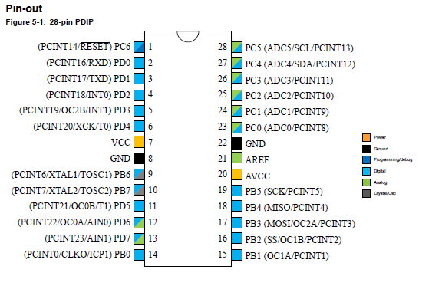

Features:

High Performance, Low Power Atmel®AVR® 8-Bit Microcontroller Family

• Advanced RISC Architecture

– 131 Powerful Instructions

– Most Single Clock Cycle Execution

– 32 x 8 General Purpose Working Registers

– Fully Static Operation

– Up to 20 MIPS Throughput at 20MHz

– On-chip 2-cycle Multiplier

• High Endurance Non-volatile Memory Segments

– 32KBytes of In-System Self-Programmable Flash program

* Memory

– 1KBytes EEPROM

– 2KBytes Internal SRAM

– Write/Erase Cycles: 10,000 Flash/100,000 EEPROM

– Data Retention: 20 years at 85°C/100 years at 25°C(1)

– Optional Boot Code Section with Independent Lock Bits

• Peripheral Features

– Two 8-bit Timer/Counters with Separate Prescaler and Compare Mode

– One 16-bit Timer/Counter with Separate Prescaler, Compare Mode, and Capture Mode

– Real Time Counter with Separate Oscillator

– Six PWM Channels

– 8-channel 10-bit ADC in TQFP and QFN/MLF package

• Temperature Measurement

– 6-channel 10-bit ADC in PDIP Package

• Temperature Measurement

– Two Master/Slave SPI Serial Interface

– One Programmable Serial USART

– One Byte-oriented 2-wire Serial Interface (Philips I2C compatible)

– Programmable Watchdog Timer with Separate On-chip Oscillator

– One On-chip Analog Comparator

– Interrupt and Wake-up on Pin Change

• Special Microcontroller Features

– Power-on Reset and Programmable Brown-out Detection

– Internal Calibrated Oscillator

– External and Internal Interrupt Sources

– Six Sleep Modes: Idle, ADC Noise Reduction, Power-save, Power-down, Standby, and

Extended Standby

• I/O and Packages

– 23 Programmable I/O Lines

– 28-pin PDIP, 32-lead TQFP, 28-pad QFN/MLF and 32-pad QFN/MLF

• Operating Voltage:

– 1.8 - 5.5V

• Temperature Range:

– -40°C to 105°C

• Speed Grade:

– 0 - 4MHz @ 1.8 - 5.5V

– 0 - 10MHz @ 2.7 - 5.5V

– 0 - 20MHz @ 4.5 - 5.5V

• Power Consumption at 1MHz, 1.8V, 25°C

– Active Mode: 0.2mA

– Power-down Mode: 0.1μA

– Power-save Mode: 0.75μA (Including 32kHz RTC)

ATmega32a

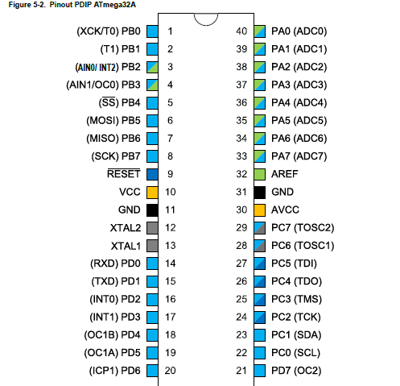

Features

• High-performance, Low-power Atmel AVR 8-bit Microcontroller

• Advanced RISC Architecture

– 131 Powerful Instructions - Most Single-clock Cycle Execution

– 32 × 8 General Purpose Working Registers

– Fully Static Operation

– Up to 16MIPS Throughput at 16MHz

– On-chip 2-cycle Multiplier

• High Endurance Non-volatile Memory segments

– 32Kbytes of In-System Self-programmable Flash program

memory

– 1024Bytes EEPROM

– 2Kbytes Internal SRAM

– Write/Erase cycles: 10,000 Flash/100,000 EEPROM

– Data retention: 20 years at 85°C/100 years at 25°C(1)

– Optional Boot Code Section with Independent Lock Bits

• Peripheral Features

– Two 8-bit Timer/Counters with Separate Prescalers and Compare Modes

– One 16-bit Timer/Counter with Separate Prescaler, Compare Mode, and Capture Mode

– Real Time Counter with Separate Oscillator

– Four PWM Channels

– 8-channel, 10-bit ADC

• 8 Single-ended Channels

• 7 Differential Channels in TQFP Package Only

• 2 Differential Channels with Programmable Gain at 1x, 10x, or 200x

– Byte-oriented Two-wire Serial Interface

– Programmable Serial USART

– Master/Slave SPI Serial Interface

– Programmable Watchdog Timer with On-chip Oscillator

– On-chip Analog Comparator

• Special Microcontroller Features

– Power-on Reset and Programmable Brown-out Detection

– Internal Calibrated RC Oscillator

– External and Internal Interrupt Sources

– Six Sleep Modes: Idle, ADC Noise Reduction, Power-save, Power-down, Standby, and

Extended Standby

• I/O and Packages

– 32 Programmable I/O Lines

– 40-pin PDIP, 44-lead TQFP, and 44-pad QFN/MLF

• Operating Voltages

– 2.7 - 5.5V

• Speed Grades

– 0 - 16MHz

• Power Consumption at 1MHz, 3V, 25°C

– Active: 0.6mA

– Idle Mode: 0.2mA

– Power-down Mode: < 1μA

ATmega2560

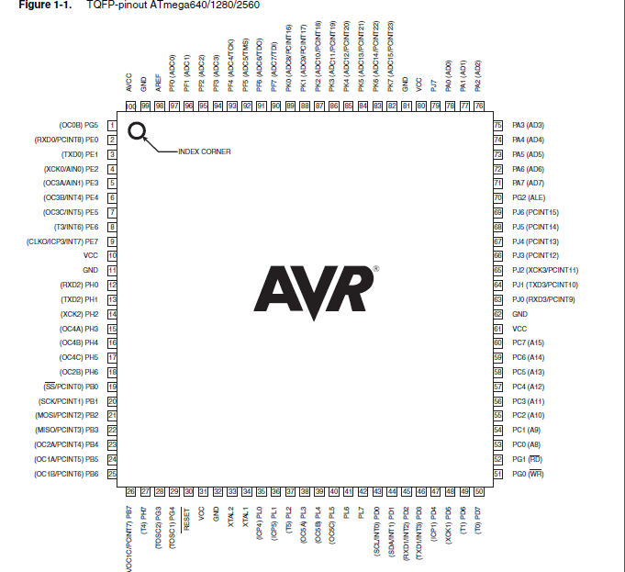

Features

• High Performance, Low Power Atmel® AVR® 8-Bit Microcontroller

• Advanced RISC Architecture

– 135 Powerful Instructions – Most Single Clock Cycle Execution

– 32 × 8 General Purpose Working Registers

– Fully Static Operation

– Up to 16 MIPS Throughput at 16MHz

– On-Chip 2-cycle Multiplier

• High Endurance Non-volatile Memory Segments

– 64K/128K/256KBytes of In-System Self-Programmable Flash

– 4Kbytes EEPROM

– 8Kbytes Internal SRAM

– Write/Erase Cycles:10,000 Flash/100,000 EEPROM

– Data retention: 20 years at 85C/ 100 years at 25C

– Optional Boot Code Section with Independent Lock Bits

• Peripheral Features

– Two 8-bit Timer/Counters with Separate Prescaler and Compare Mode

– Four 16-bit Timer/Counter with Separate Prescaler, Compare- and Capture Mode

– Real Time Counter with Separate Oscillator

– Four 8-bit PWM Channels

– Six/Twelve PWM Channels with Programmable Resolution from 2 to 16 Bits

(ATmega1281/2561, ATmega640/1280/2560)

– Output Compare Modulator

– 8/16-channel, 10-bit ADC (ATmega1281/2561, ATmega640/1280/2560)

– Two/Four Programmable Serial USART (ATmega1281/2561, ATmega640/1280/2560)

– Master/Slave SPI Serial Interface

– Byte Oriented 2-wire Serial Interface

– Programmable Watchdog Timer with Separate On-chip Oscillator

– On-chip Analog Comparator

– Interrupt and Wake-up on Pin Change

• Special Microcontroller Features

– Power-on Reset and Programmable Brown-out Detection

– Internal Calibrated Oscillator

– External and Internal Interrupt Sources

– Six Sleep Modes: Idle, ADC Noise Reduction, Power-save, Power-down, Standby,

and Extended Standby

• I/O and Packages

– 54/86 Programmable I/O Lines (ATmega1281/2561, ATmega640/1280/2560)

– 64-pad QFN/MLF, 64-lead TQFP (ATmega1281/2561)

– 100-lead TQFP, 100-ball CBGA (ATmega640/1280/2560)

– RoHS/Fully Green

• Temperature Range:

– -40C to 85C Industrial

• Ultra-Low Power Consumption

– Active Mode: 1MHz, 1.8V: 500μA

– Power-down Mode: 0.1μA at 1.8V